|  |  |  |
| --- | --- | --- |
|  | | |
| Федеральное государственное бюджетное  образовательное учреждение высшего образования «Новосибирский государственный технический университет» | | |
|  | | |
| Кафедра прикладной математики | | |
| Практическое задание №9 1 | | |
| по дисциплине «Методы принятия оптимальных решений» | | |
| **Лексикографическая модификация** **метода последовательного уточнения оценок** | | |
|  | | |
|  | Бригада: | ПМ-13 БуданцеВ дмитрий |
| . | ПМ-13 Форкин кирилл |
|  |  |
|  |  |
|  |  |
|  |  |
| Преподаватели | Лемешко Борис Юрьевич |
|  |  |
| Новосибирск,2024 | | |

# **Задание**

Решить следующую задачу первым и вторым алгоритмами Гомори:

при

# **Решение первым алгоритмом Гомори**

Для нахождения -нормальной таблицы. Добавим одно ограничение

*,*

которое не противоречит заданным ограничениям.

1.

|  |  |  |  |
| --- | --- | --- | --- |
|  |  |  |  |
|  | 0 | -4 | -3 |
|  | 0 | -1 | 0 |
|  | 0 | 0 | -1 |
|  | 6 | 1 | 2 |
|  | 15 | 5 | 3 |
|  | 2 | -1 | 1 |
|  | 2 | 1 | -1 |
|  | 14 | 4 | 3 |

3.

|  |  |  |  |
| --- | --- | --- | --- |
|  |  |  |  |
|  | 14.00 | 0.00 | 1.00 |
|  | 2.00 | -0.60 | 0.40 |
|  | 2.00 | 0.80 | -0.20 |
|  | 0.00 | -1.00 | 0.00 |
|  | -1.00 | 0.60 | -1.40 |
|  | 2.00 | -1.40 | 0.60 |
|  | 2.00 | 1.40 | -0.60 |
|  | 0.00 | 0.00 | -1.00 |

2. (-нормальная таблица)

|  |  |  |  |
| --- | --- | --- | --- |
|  |  |  |  |
|  | 14.00 | 0.00 | 1.00 |
|  | 0.00 | -1.00 | 0.00 |
|  | 4.67 | 1.33 | 0.33 |
|  | -3.33 | -1.67 | -0.67 |
|  | 1.00 | 1.00 | -1.00 |
|  | -2.67 | -2.33 | -0.33 |
|  | 6.67 | 2.33 | 0.33 |
|  | 0.00 | 0.00 | -1.00 |

4.

|  |  |  |  |
| --- | --- | --- | --- |
|  |  |  |  |
|  | 14.00 | 0.00 | 1.00 |
|  | 1.00 | 1.00 | -1.00 |
|  | 3.33 | -1.33 | 1.67 |
|  | -1.67 | 1.67 | -2.33 |
|  | 0.00 | -1.00 | 0.00 |
|  | -0.33 | 2.33 | -2.67 |
|  | 4.33 | -2.33 | 2.67 |
|  | 0.00 | 0.00 | -1.00 |

5.

|  |  |  |  |
| --- | --- | --- | --- |
|  |  |  |  |
|  | 13.29 | 0.71 | 0.43 |
|  | 1.71 | 0.29 | -0.43 |
|  | 2.14 | -0.14 | 0.71 |
|  | 0.00 | 0.00 | -1.00 |
|  | 0.00 | -1.00 | 0.00 |
|  | 1.57 | 0.43 | -1.14 |
|  | 2.43 | -0.43 | 1.14 |
|  | 0.71 | -0.71 | -0.43 |
|  | -0.29 | -0.71 | -0.43 |

7.

|  |  |  |  |
| --- | --- | --- | --- |
|  |  |  |  |
|  | 13.00 | 0.00 | 1.00 |
|  | 1.00 | 1.50 | -2.00 |
|  | 3.00 | -2.00 | 3.00 |
|  | -1.00 | 2.50 | -4.00 |
|  | 1.00 | -1.50 | 1.00 |
|  | 0.00 | 3.50 | -5.00 |
|  | 4.00 | -3.50 | 5.00 |
|  | 1.00 | 0.00 | -1.00 |

9.

|  |  |  |  |
| --- | --- | --- | --- |
|  |  |  |  |
|  | 12.00 | 0.00 | 1.00 |
|  | 3.00 | 1.50 | -2.00 |
|  | 0.00 | -2.00 | 3.00 |
|  | 3.00 | 2.50 | -4.00 |
|  | 0.00 | -1.50 | 1.00 |
|  | 5.00 | 3.50 | -5.00 |
|  | -1.00 | -3.50 | 5.00 |
|  | 2.00 | 0.00 | -1.00 |

11.

|  |  |  |  |
| --- | --- | --- | --- |
|  |  |  |  |
|  | 12.00 | 0.00 | 1.00 |
|  | 2.00 | 1.00 | 0.00 |
|  | 1.33 | -1.33 | 0.33 |
|  | 1.33 | 1.67 | -0.67 |
|  | 1.00 | -1.00 | -1.00 |
|  | 2.67 | 2.33 | -0.33 |
|  | 1.33 | -2.33 | 0.33 |
|  | 2.00 | 0.00 | -1.00 |
|  | -0.33 | -0.67 | -0.33 |

6.

|  |  |  |  |
| --- | --- | --- | --- |
|  |  |  |  |
|  | 13.00 | 0.00 | 1.00 |
|  | 2.00 | 1.00 | -1.00 |
|  | 1.67 | -1.33 | 1.67 |
|  | 0.67 | 1.67 | -2.33 |
|  | 0.00 | -1.00 | 0.00 |
|  | 2.33 | 2.33 | -2.67 |
|  | 1.67 | -2.33 | 2.67 |
|  | 1.00 | 0.00 | -1.00 |
|  | -0.67 | -0.67 | -0.67 |

8.

|  |  |  |  |
| --- | --- | --- | --- |
|  |  |  |  |
|  | 12.75 | 0.63 | 0.25 |
|  | 1.50 | 0.25 | -0.50 |
|  | 2.25 | -0.13 | 0.75 |
|  | 0.00 | 0.00 | -1.00 |
|  | 0.75 | -0.88 | 0.25 |
|  | 1.25 | 0.38 | -1.25 |
|  | 2.75 | -0.38 | 1.25 |
|  | 1.25 | -0.63 | -0.25 |
|  | -0.75 | -0.63 | -0.25 |

10.

|  |  |  |  |
| --- | --- | --- | --- |
|  |  |  |  |
|  | 12.00 | 0.00 | 1.00 |
|  | 2.57 | 0.43 | 0.14 |
|  | 0.57 | -0.57 | 0.14 |
|  | 2.29 | 0.71 | -0.43 |
|  | 0.43 | -0.43 | -1.14 |
|  | 4.00 | 1.00 | 0.00 |
|  | 0.00 | -1.00 | 0.00 |
|  | 2.00 | 0.00 | -1.00 |
|  | -0.57 | -0.43 | -0.14 |

12.

|  |  |  |  |
| --- | --- | --- | --- |
|  |  |  |  |
|  | 12.00 | 0.00 | 1.00 |
|  | 1.50 | 1.50 | -0.50 |
|  | 2.00 | -2.00 | 1.00 |
|  | 0.50 | 2.50 | -1.50 |
|  | 1.50 | -1.50 | -0.50 |
|  | 1.50 | 3.50 | -1.50 |
|  | 2.50 | -3.50 | 1.50 |
|  | 2.00 | 0.00 | -1.00 |
|  | -0.50 | -0.50 | -0.50 |

14.

|  |  |  |  |
| --- | --- | --- | --- |
|  |  |  |  |
|  | 11.50 | 1.25 | 0.25 |
|  | 1.00 | 0.50 | -0.50 |
|  | 2.50 | -0.25 | 0.75 |
|  | 0.00 | 0.00 | -1.00 |
|  | 2.50 | -1.75 | 0.25 |
|  | 0.50 | 0.75 | -1.25 |
|  | 3.50 | -0.75 | 1.25 |
|  | 2.50 | -1.25 | -0.25 |
|  | -0.50 | -0.25 | -0.25 |

13.

|  |  |  |  |
| --- | --- | --- | --- |
|  |  |  |  |
|  | 12.00 | 0.00 | 1.00 |
|  | 0.00 | 3.00 | -2.00 |
|  | 4.00 | -4.00 | 3.00 |
|  | -2.00 | 5.00 | -4.00 |
|  | 3.00 | -3.00 | 1.00 |
|  | -2.00 | 7.00 | -5.00 |
|  | 6.00 | -7.00 | 5.00 |
|  | 2.00 | 0.00 | -1.00 |

15.

|  |  |  |  |
| --- | --- | --- | --- |
|  |  |  |  |
|  | 11.00 | 1.00 | 1.00 |
|  | 2.00 | 1.00 | -2.00 |
|  | 1.00 | -1.00 | 3.00 |
|  | 2.00 | 1.00 | -4.00 |
|  | 2.00 | -2.00 | 1.00 |
|  | 3.00 | 2.00 | -5.00 |
|  | 1.00 | -2.00 | 5.00 |
|  | 3.00 | -1.00 | -1.00 |

Таким образом, ответ с нецелочисленным планом:

Ответ с целочисленным планом:

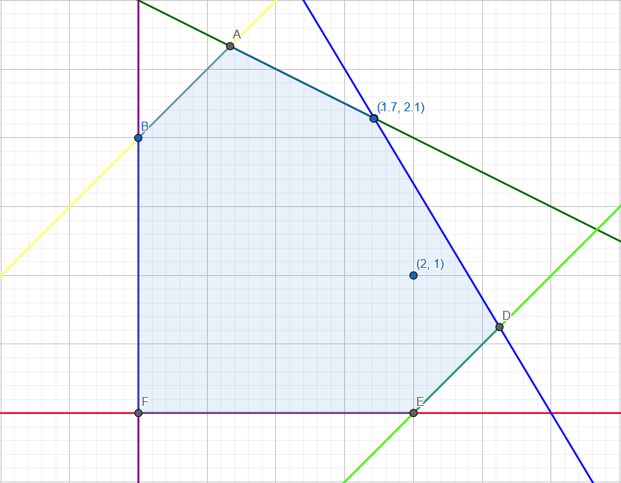

# **Решение вторым алгоритмом Гомори**

Первые шаги алгоритма (когда находится нецелочисленные решения) идентичны с первым алгоритмом, поэтому решение начнём с 5 шага первого алгоритма Гомори.

5.

|  |  |  |  |
| --- | --- | --- | --- |
|  |  |  |  |
|  | 13.29 | 0.71 | 0.43 |
|  | 1.71 | 0.29 | -0.43 |
|  | 2.14 | -0.14 | 0.71 |
|  | 0.00 | 0.00 | -1.00 |
|  | 0.00 | -1.00 | 0.00 |
|  | 1.57 | 0.43 | -1.14 |
|  | 2.43 | -0.43 | 1.14 |
|  | 0.71 | -0.71 | -0.43 |
|  | -0.29 | -0.11 | -0.23 |

7.

|  |  |  |  |
| --- | --- | --- | --- |
|  |  |  |  |
|  | 12.00 | 0.00 | 1.00 |
|  | 3.00 | 1.00 | -1.00 |
|  | 0.00 | -1.33 | 1.67 |
|  | 3.00 | 1.67 | -2.33 |
|  | 0.00 | -1.00 | 0.00 |
|  | 5.00 | 2.33 | -2.67 |
|  | -1.00 | -2.33 | 2.67 |
|  | 2.00 | 0.00 | -1.00 |

9.

|  |  |  |  |
| --- | --- | --- | --- |
|  |  |  |  |
|  | 12.00 | 0.00 | 1.00 |
|  | 2.00 | 1.00 | 0.00 |
|  | 1.33 | -1.33 | 0.33 |
|  | 1.33 | 1.67 | -0.67 |
|  | 1.00 | -1.00 | -1.00 |
|  | 2.67 | 2.33 | -0.33 |
|  | 1.33 | -2.33 | 0.33 |
|  | 2.00 | 0.00 | -1.00 |
|  | -0.33 | 0.33 | -0.33 |

6.

|  |  |  |  |
| --- | --- | --- | --- |
|  |  |  |  |
|  | 12.75 | 0.50 | 1.87 |
|  | 2.25 | 0.50 | -1.87 |
|  | 1.25 | -0.50 | 3.12 |
|  | 1.25 | 0.50 | -4.37 |
|  | 0.00 | -1.00 | 0.00 |
|  | 3.00 | 1.00 | -5.00 |
|  | 1.00 | -1.00 | 5.00 |
|  | 1.25 | -0.50 | -1.87 |
|  | -0.75 | -0.50 | -1.87 |

8.

|  |  |  |  |
| --- | --- | --- | --- |
|  |  |  |  |
|  | 12.00 | 0.00 | 1.00 |
|  | 2.57 | 0.43 | 0.14 |
|  | 0.57 | -0.57 | 0.14 |
|  | 2.29 | 0.71 | -0.43 |
|  | 0.43 | -0.43 | -1.14 |
|  | 4.00 | 1.00 | 0.00 |
|  | 0.00 | -1.00 | 0.00 |
|  | 2.00 | 0.00 | -1.00 |
|  | -0.57 | -0.43 | -0.14 |

10.

|  |  |  |  |
| --- | --- | --- | --- |
|  |  |  |  |
|  | 11.00 | 1.00 | 3.00 |
|  | 2.00 | 1.00 | 0.00 |
|  | 1.00 | -1.00 | 1.00 |
|  | 2.00 | 1.00 | -2.00 |
|  | 2.00 | -2.00 | -3.00 |
|  | 3.00 | 2.00 | -1.00 |
|  | 1.00 | -2.00 | 1.00 |
|  | 3.00 | -1.00 | -3.00 |

Таким образом, ответ, полученный вторым алгоритмом Гомори, совпадает с ответом, полученным первым алгоритмом. В данном случае второй алгоритм Гомори получил решение быстрее первого алгоритма.